TRAFFORD COUNCIL

Report to: Safety at Sports Grounds Sub Committee
Date: 28th May 2009.
Report for: Information
Report of: Director of Environment

Report Title

Lancashire County Cricket Club – Phase 1 Stadium Development (Hospitality Suite and Spectator Viewing Facility).

Summary

Report detailing the proposed four storey Hospitality and Spectator Viewing Facility.

Recommendation

That the Report be noted.

Contact person for access to background papers and further information:

Name: Alan Finney
Extension: 1011

Background Papers:

Financial Implications:
Legal Implications:
Human Resources Implications:
Asset Management Implications:
E-Government Implications:
Risk Management Implications:

Lancashire County Cricket Club

New Hospitality and Spectator Viewing Facility.

Lancashire County Cricket Club is undergoing a re-development of their Old Trafford Stadium.

Phase One of the re-development is a new four storey Hospitality and Spectator Viewing building.

This building replaces the Tyldesley Suite, County Restaurant and the Board of Control Stand. The demolition of these buildings began in December 2008 and was completed in April 2009.

In December 2008 a large Hospitality Marquee was erected on the car park facing Talbot Road. This marquee provides hospitality, both corporate and matchday, until the new Hospitality building becomes available.

The construction of the new building began on the 20th April 2009 and is scheduled for hand over on the 1st June 2010. During this period the Stadium capacity, for the viewing of cricket matches, is reduced to 13,294. This figure would be increased to 18,532 if a temporary stand is introduced into the Stadium.

The development consists of a spectator seating stand and a hospitality and events building, situated behind and above the stand, in the North West end of the Ground.
The stand is separated from the hospitality and events building by an open concourse, with the exception of a link bridge between the 1st floor of the events building and the lateral gangway situated at the top of the stand.
The hospitality and events building will accommodate an events hall facility, events reception space with bar, circulation spaces, staff facilities, kitchen areas, plant and services areas.
Key features of the development include:
• The stand will be designed to accommodate 2250 spectators (1250 general spectators,1000 premium spectators);
• The stand will typically be accessed via the open concourse at ground floor (general spectators) and via the hospitality accommodation at 1st floor (premium spectators)
• The events building consists of four storeys (ground + 3 upper floors);
• The height of the floor of the top storey of the building is 14.4m above the ground.
• The footprint of the new hospitality and events building is 770 m².
• A lightwell is provided within the building, extending the full height of the hospitality building from ground floor to the roof.

A section through the development is shown below, with the important features highlighted.

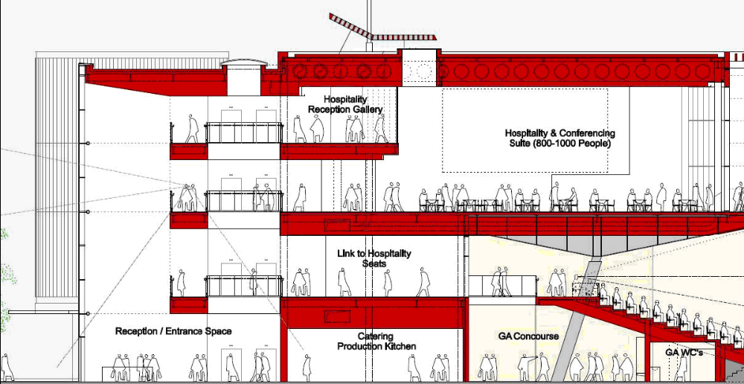

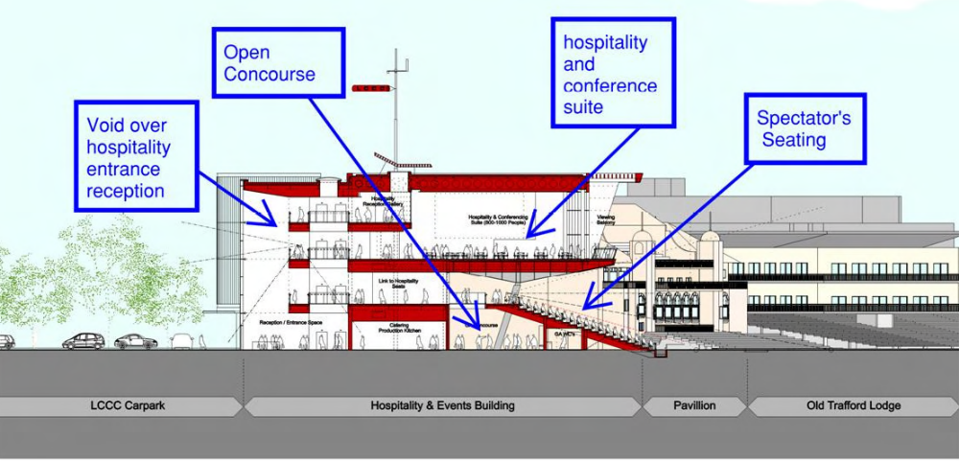
Section through the LCCC development.

The building may be used in three different modes of operation:

1. Main field of play events when the stand, the hospitality building and the whole ground will be occupied by the public (i.e. test cricket matches, concerts, etc) attending a single event.
2. Hospitality events where no event is held on the field of play and only the hospitality building is occupied by the public (i.e hired for a particular use such as conferences, corporate events, weddings etc). This is also applicable for day-to-day use.
3. Small field of play events when the ground will only have a sparse public attendance (i.e. county cricket) and the hospitality building may be used for a separate event.

The following guidance documents has been used in the design and construction of the development:

- The Guide to Safety at Sports Grounds (‘Green Guide’), published by the Department of Culture, Media and Sport (DCMS)
- Approved Document B 2006 of the Building Regulations
- British Standards

Additionally, as the functions of the facilities are considered separately, relevant guidance will be applied to each part of the building:
- The stand and concourse areas will be designed based on the recommendations of the Guide to Safety at Sports Grounds.
- The hospitality building will be designed to be constructed as a “Place of Assembly” for the purposes of the Building Regulations Part B and the design will be based on the recommendations given in Approved Document B for Assembly and Recreation buildings.

Fire Engineering has been applied and is recognised in the referenced design guides as an acceptable method for achieving alternative solutions where meeting the prescribed Code guidance is not feasible or achievable. All fire engineered elements require consultation and agreement between all interested parties such as the Club, Building Control and the Fire Authority. This thereby enables a full understanding of the issues taking into account the potential functions of the facilities, the number and familiarity of occupants with their surroundings and the planned staffing levels.

During the course of the construction period the Stadium will continue to operate as normal for cricket matches and pop concerts.

The construction site will be enclosed and secured by the erection of site hoardings. These site hoardings will be crowd loaded in accordance with loadings required by the Building Regulations and the Guide to Safety at Sports Grounds.

The footprint of the construction site will be reduced during the pop concerts in June and September 2009. This will involve the resiting of the site hoardings and re-erecting them with reviewed crowd loadings which will be dependant on their new location. The new arrangements will be designed to facilitate improved crowd movement and circulation during the concert periods. The major construction works will be suspended during the concert periods and any construction work undertaken during the concert will only take place following agreement with the Club and the enforcing authorities.

A comprehensive Stewarding Plan will be submitted as part of the Event Safety Procedures Manual for the concert.

